Exercise 10: Copying and Moving Jobs
I. Copying Jobs

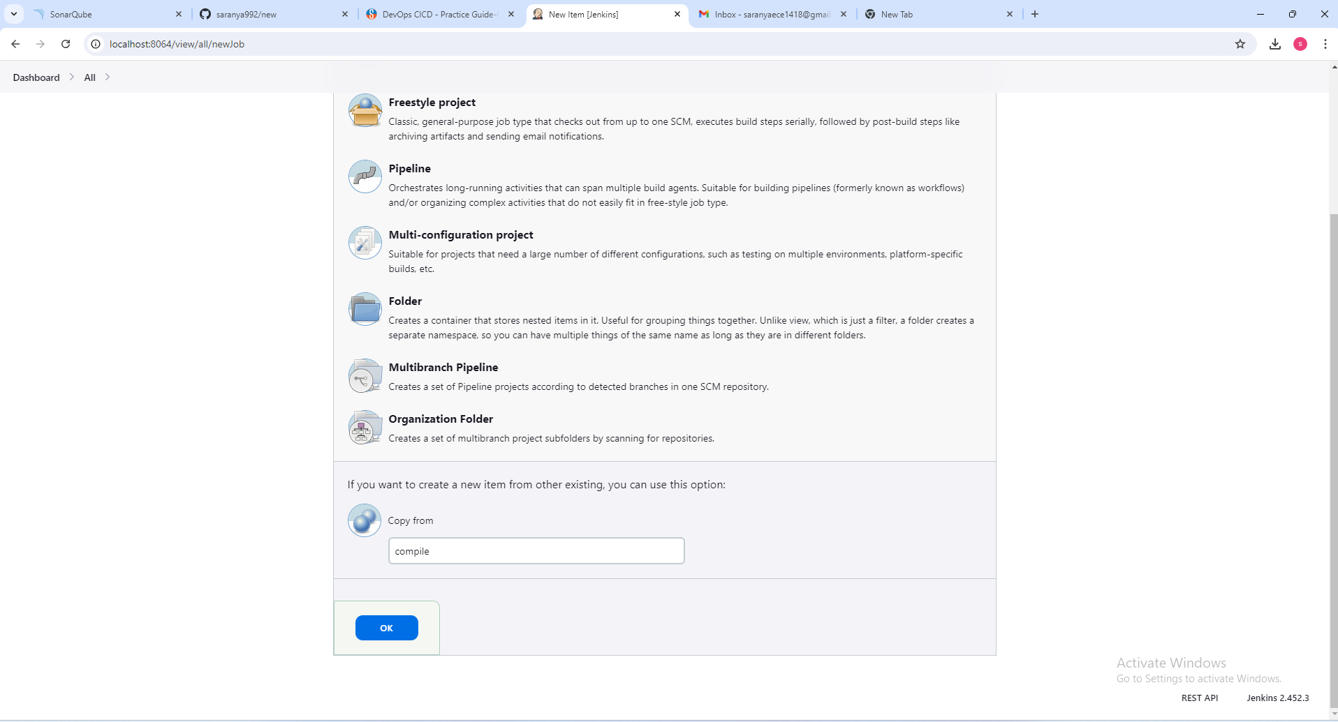
II. Moving Jobs:

CLICK MOVE OPTION TO MOVE THE FILE TO THE FOLDER
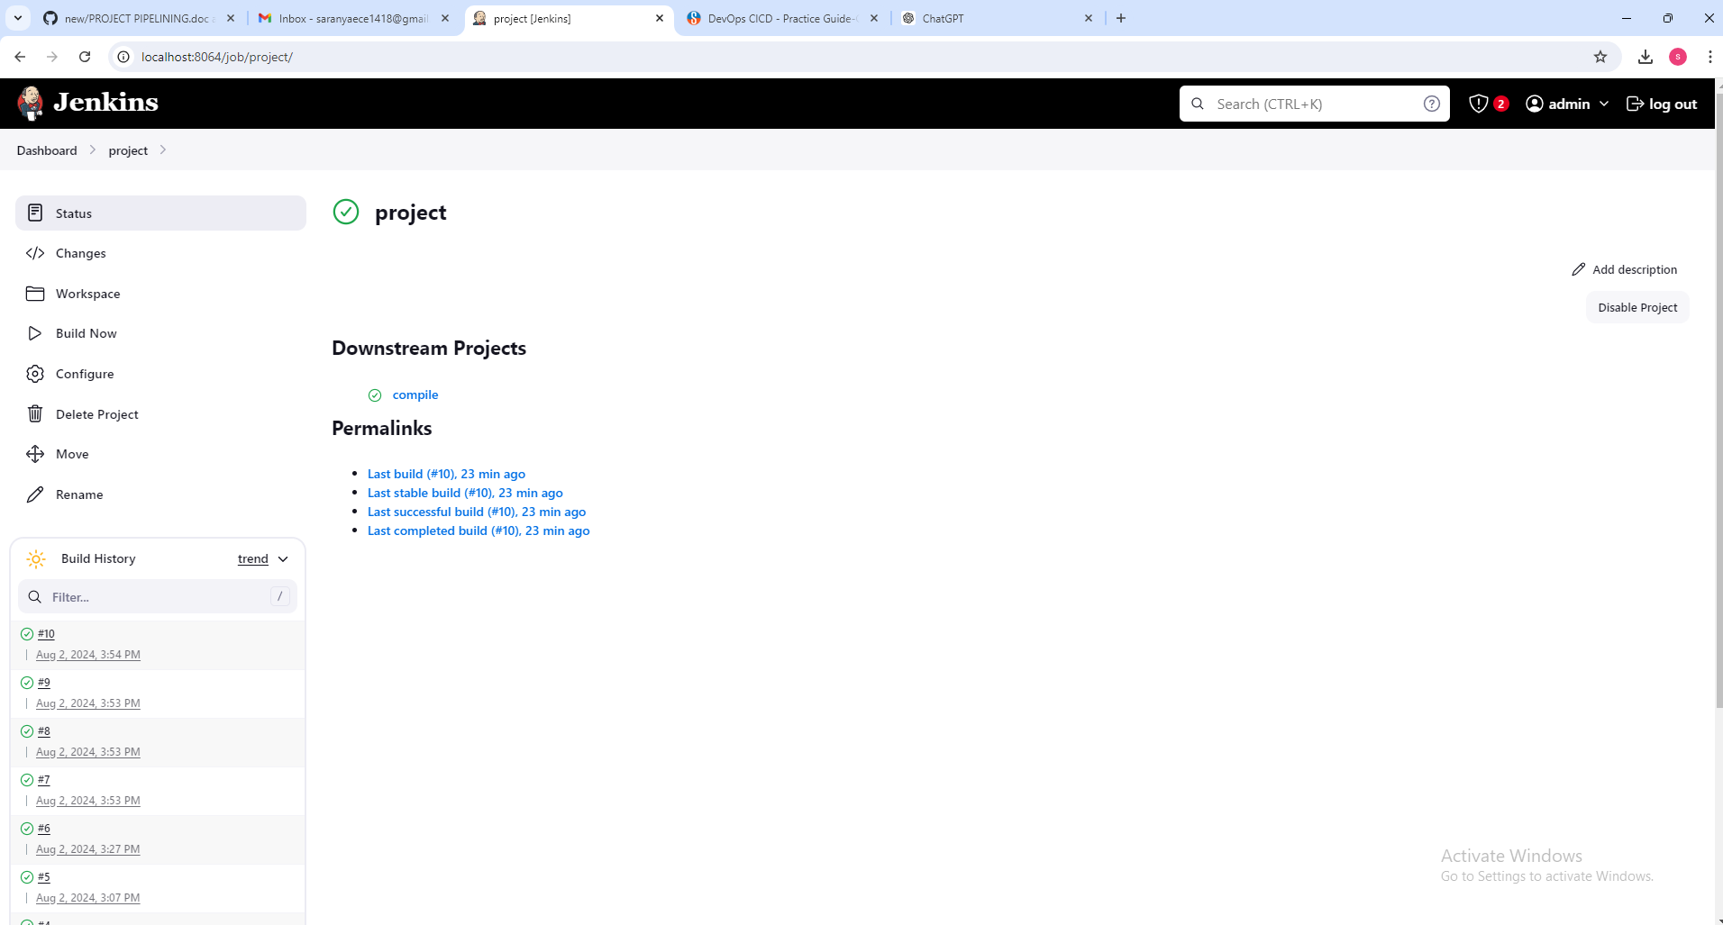

Step 4: Click on Move and observe the newly moved jobs in that location

MOVE THE FILE TO THE FOLDER NAMED AS “FOLDER”
